Predict Churn Rate Using Random forests and glmnet using k-fold validation and ensuring using the same train test sets for both models for better comparisons.

# Create bwplot of the model's out of sample scores

bwplot(resamples, metric = "ROC")

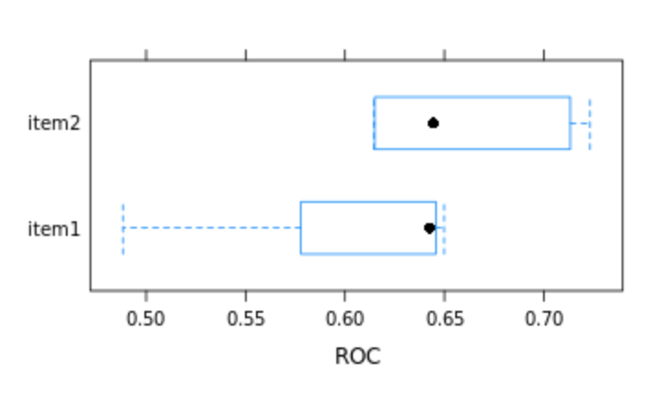

# Create xyplot shows you how similar the two models' performances are on different folds.

xyplot(resamples, metric = "ROC")

